Northwind Customer Order Form

# Order Form- First Visit

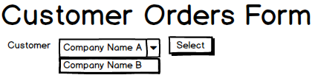

|  |  |  |
| --- | --- | --- |
| Form/UI | BLL Processing | Entities/DTOs/POCOs |
| CustomerDropDownList  (bound to ObjectDataSource) | SalesController  .ListCustomerNames()  : List<KeyValueOption> | KeyValueOption  - Key  - Text |
| SelectCustomer (LinkButton)  (OnClick)  *This method programmatically populates the Company/Contact/Phone/Fax as shown in the next screen design* | SalesController  .GetCustomerSummary(CustomerID)  : CustomerSummary | CustomerSummary  - CompanyName  - ContactName  - PhoneNumber  - FaxNumber |

# Order Form – Customer Selected

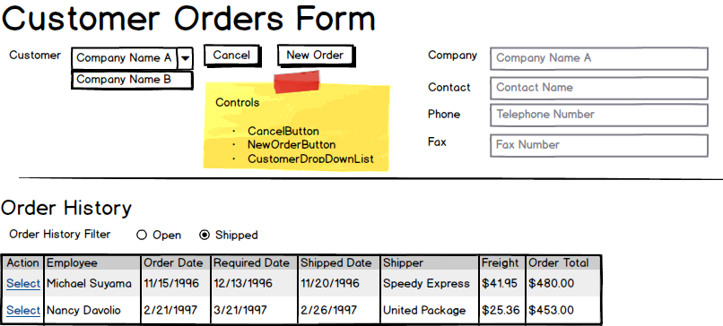

|  |  |  |
| --- | --- | --- |
| Form/UI | BLL Processing | Entities/DTOs/POCOs |
| Order History Filter (RadioButtonList)  (ObjectDataSource) | SalesController  .GetOrderHistoryFilters()  : List<KeyValueOption> | KeyValueOption (POCO)  - Key  - Text |
| Order History (GridView)  (ObjectDataSource)  - CustomerID = CustomerDropDownList.SelectedValue  - Filter = OrderHistoryFilter.SelectedValue | SalesController  .GetOrdersByCustomer(CustomerID, Filter)  : List<CustomerOrder>  - *Builds the data from the* Order, OrderDetail, Product, *and* Employee *entities* | CustomerOrder (POCO)  - OrderID  - EmployeeName  - OrderDate  - RequiredDate  - ShippedDate  - ShipperName  - FreightCost  - OrderTotal |